**Excel Assignment 3**

1. What do you mean by “Relative Cell Referencing” in MS Excel and “Absolute cell referencing”?

A cell reference is a relative reference, which means that **the reference is relative to the location of the cell**. If, for example, you refer to cell A2 from cell C2, you are actually referring to a cell that is two columns to the left (C minus A)—in the same row (2).

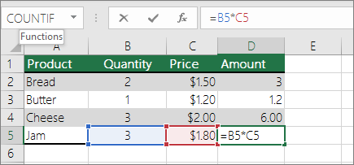

An absolute cell reference is **a cell reference in a spreadsheet application that remains constant even if the shape or size of the spreadsheet is changed, or the reference is copied or moved to another cell or sheet**. Absolute cell references are important when referring to constant values in a spreadsheet.

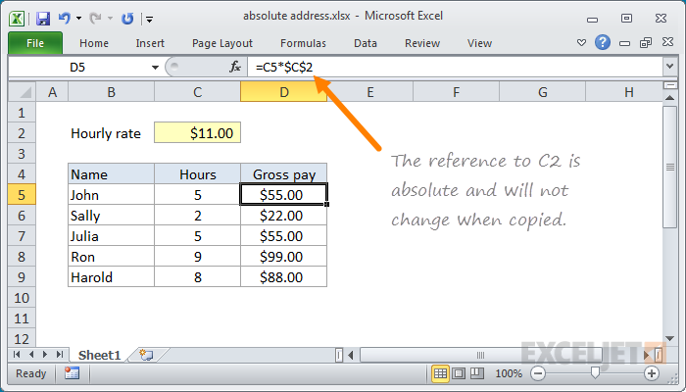

1. How to secure an excel workbook, demonstrate it with an example.

* Select File > Review.
* Select the Protect Workbook box and choose Encrypt with Password.
* Enter a password in the Password box, and then select OK.
* Confirm the password in the Re-enter Password box, and then select OK.

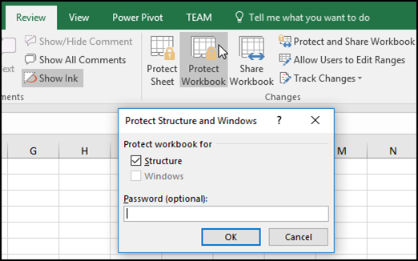

1. Explain the pivot tables and their implementations.

A pivot table is **a statistics tool that summarizes and reorganizes selected columns and rows of data in a spreadsheet or database table to obtain a desired report**. The tool does not actually change the spreadsheet or database itself, it simply “pivots” or turns the data to view it from different perspectives.

## Step to Create a Pivot Table:-

## Enter your data into a range of rows and columns.

## Sort your data by a specific attribute.

## Highlight your cells to create your pivot table.

## Drag and drop a field into the "Row Labels" area.

## Drag and drop a field into the "Values" area.

## Fine-tune your calculations.

1. Explain lookup in excel with suitable examples.

The Microsoft Excel LOOKUP function **returns a value from a range (one row or one column) or from an array**. The LOOKUP function is a built-in function in Excel that is categorized as a Lookup/Reference Function. It can be used as a worksheet function (WS) in Excel.

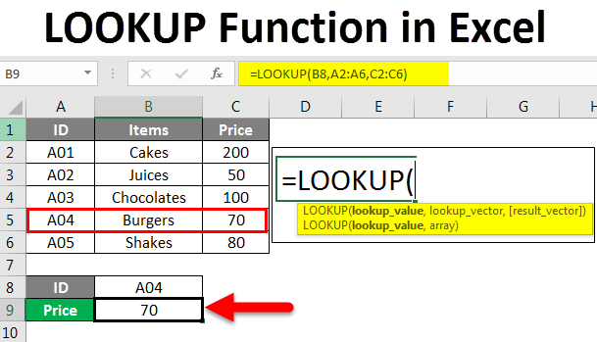

1. What is Data validation, and how to implement it in Excel?

Excel data validation is **a feature that allows you to control the type of data entered into your worksheet**. For example, Excel data validation allows you to limit data entries to a selection from a dropdown list and to restrict certain data entries, such as dates or numbers outside of a predetermined range.

